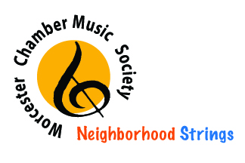
Neighborhood Strings
Agreement: Use of Cello

I, the undersigned, am the parent/legal guardian of _____________________________
^{[name of child]}
who is a participant in Neighborhood Strings. I understand that my child/ward has been granted permission to borrow a cello, including the bow and the case, (hereinafter collectively referred to as “cello”) for use in the Program. I also understand that the cello is a delicate instrument and that special care will need to be taken to protect the instrument.

In consideration of my child’s being permitted to use the cello, I agree to pay a non-refundable fee of $25.00 per semester to borrow the cello and to accept full responsibility for the care of the cello. I also understand and agree that if the cello is not returned by the agreed upon return date, the end of the current NS season or upon leaving the program, it will be considered lost. Additionally, I agree not to permit anyone else to use the instrument during the time period that it is signed out in my child’s name and to take necessary precautions to ensure that my child/ward does not allow anyone else to use the cello.

I acknowledge that I have read and understand the terms of this agreement and that I am of legal age to bind myself to this agreement. This agreement has been executed on behalf of myself, my heirs and assigns. This instrument has been executed in and shall be interpreted according to the laws of the state of Massachusetts.

Parent Name:___________________________________ Date:__________________

Parent Signature:___________________________________
---------------------------------------------------------------------------------------------------------------------

(to be filled out by NS)

Cello #:________________________

Music Stand?_______________
Cello

